DRB Ignite Multi Academy Trust

DATA SUBJECT CONSENT FORM (TIER 4)

GDPR consent statement

  - I, [data subject name], hereby grant <School Name> and [third-party processor] authority to process my personal data for the purpose of [school needs to specify in explicit terms, the personal data type data and the legitimate reasons for processing the personal data, in accordance with GDPR Article 6, 1 (a-f)], which is attached to this declaration.
  - I am aware that I may withdraw my consent at any time by using the GDPR REC 4.6A – Data Subject Consent Withdrawal Form.

Signed by data subject:

Date:

Request actioned:

Data Protection Officer:

Date:

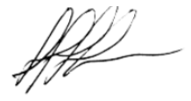
This work instruction was approved by the Data Protection Officer and is issued on a version-controlled basis under his/her signature

Signature: Date: 1/5/2018

Change History Record

Issue | Description of Change | Approval | Date of Issue
1 | Initial issue | - Walters | 1/5/2018

