Year 5 Autumn Term Home Learning
Set on: Tuesday 22nd September
Due into school on: Monday 18th October
Discussed and shared in class on: Friday 22nd October
Home learning is going to be slightly different this year due to the situation we are in.
In English we will be reading and writing using this story written by Philip Pullman.
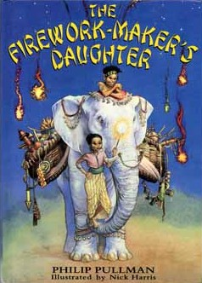

These will be your child’s spelling list for the half term.
WC 6.9.21 | WC 13.9.21 | WC 20.9.21 | WC 27.9.21 | WC 4.10.21
optician | illuminate | redecorate | accompany | adorable
pyramid | admiration | mention | amateur | adorably
trouble | possession | position | bargain | applicable
incomplete | foundation | weather | bruise | applicably
peace | forgotten | whether | community | considerable
country | gardening | obvious | competition | considerably
piece | great | completion | explanation | tolerable
vein | grate | mountainous | guarantee | tolerably
weigh | fascinate | tongue | individual | capable
parachute | expression | scheme | prejudice | knowledgeable

In Maths we will be learning:
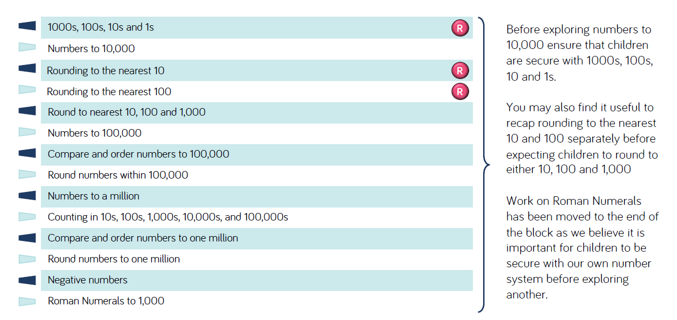
These websites might be useful
https://www.topmarks.co.uk/maths-games/hit-the-button
https://www.primarygames.co.uk/pg2/splat/splatsq100.html

Please select and complete at least 3 of the tasks below. Please bring your Home Learning so we can share your fantastic home learning in class and we will display as many of the items as possible.
I hope you enjoy developing your own knowledge and understanding.
Task 1  Geography - Volcanoes  Create a 3D model of a ‘volcano’ using recyclable materials from around your home and take a photograph to bring to school for a show and tell.  These links may be useful…  https://www.learning4kids.net/2012/04/11/how-to-make-a-homemade-volcano/  https://sciencebob.com/make-your-own-volcano/ | Task 2  Geography - Earthquakes  Research what an earthquake is and create an information leaflet.  How are they made?  Where do they occur?  Why do they happen?  What is the impact on countries, cities and towns.  These links may be useful…  https://www.bbc.co.uk/bitesize/topics/z849q6f/articles/zj89t39  https://www.weatherwizkids.com/weather-earthquake.htm | Helpful hints:  Tick the activities and date them when you have completed them.  For finding out activities, use: the internet safely ,  books ,  other people ,  library,  things you’ve learned in school.  You can use:  pencil & paper 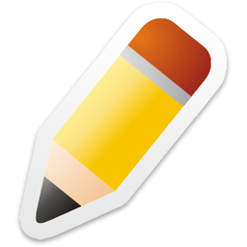,  cameras ,  tablets 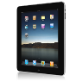,  smart phones ,  PCs 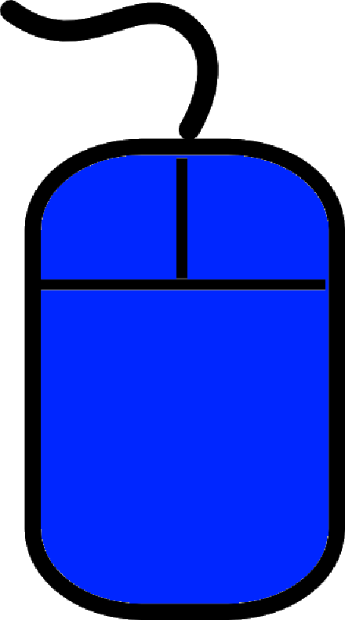,  anything you want:  BE CREATIVE!
Task 3  Science – Physics – Forces  Research different forces that occur around your home – pushes, pulls, gravity, friction, air resistance, water resistance and magnetism.  Take photographs of these forces around your home and write an explanation about what is happening in the photo.  These links may be useful…  https://www.bbc.co.uk/bitesize/topics/znmmn39  https://www.lovemyscience.com/facts-forces.html | Task 4  RE – Islam  Research the religion of Islam and create a fact file.  The Five pillars of Islam – What are they and what do they represent?  What is a mosque?  What is the Qur’an?  These links may be useful…  http://www.primaryhomeworkhelp.co.uk/religion/Islam.htm  https://www.bbc.co.uk/teach/class-clips-video/religious-education-ks2-my-life-my-religion-what-is-islam/zbmrwty
Task 5
English – Journey by Aaron Becker

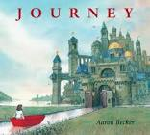
Compose your own ‘Journey’ narrative story
with you as the main character travelling through
different lands and worlds with your magic crayon,
meeting interesting characters and having exciting adventures.

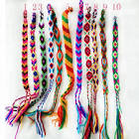
Task 6
Christian Values – Friendship

Design and make your own friendship bracelet(s)
for your family, school friends and teachers.
These links may be useful…
https://www.projectswithkids.com/friendship-bracelets/

https://www.artistshelpingchildren.org/kidscraftsactivitiesblog/2011/01/how-to-make-friendship-bracelets-easy-step-by-step-tutorial-for-kids/

If you have any questions, please speak to me or Mrs Reynolds-Lawrence. We hope you enjoy your learning!!

