Year 4
Autumn 1 Home Learning
Set on: 13.09.2021

Please select and complete at least 3 of the tasks below. On Monday 18th October please bring your Home Learning to school so we can share your fantastic work in class and we will display as many of the items as possible. I hope you enjoy developing your own knowledge and understanding.

Task 1  Draw three animals and find out what habitat they live in.  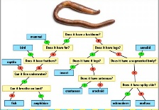  Present your information in a poster, writing your answers and information in full sentences.  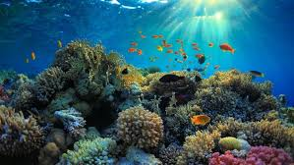 | Task 2  Create a fact file about an endangered species.  https://www.worldwildlife.org/species/directory?direction=desc&sort=extinction_status | Helpful hints:  Tick the activities and date them when you have completed them.  For finding out activities, use: the internet safely ,  books ,  other people ,  library,  things you’ve learned in school.  You can use:  pencil & paper ,  cameras ,  tablets ,  smart phones ,  PCs ,  anything you want: be creative!
Task 3  Choreograph a dance to mimic the way different types of vertebrate move. E.g. bee dance | Task 4  Choose 4 animals and make a classification key to identify them. Remember, classification keys use ‘yes’ or ‘no’ questions.  https://www.bbc.co.uk/bitesize/topics/zn22pv4/articles/z3nbcwx
Task 5
Go on a walk and explore your local park. Use the leaf ID sheet to identify and name a selection of hand-picked leaves.
Observe three of the leave you have found and write a detailed description of them explaining their similarities and differences.
https://www.woodlandtrust.org.uk/media/48345/leaf-id-sheet.pdf
Task 6
Watch the video about how humans effect ecosystem.
Investigate the causes, impact and possible solutions to one of the environmental issues below:
air pollution ocean pollution
deforestation litter
https://www.bbc.co.uk/bitesize/topics/zp22pv4/articles/z2md82p
Some useful websites:
- http://wildlife.durrell.org/kids/fun-factsheets/habitats-factsheet/
- https://www.natgeokids.com/uk/
- https://interestingengineering.com/11-ways-humans-impact-the-environment

If you have any questions, please speak to me or Mrs Lal. We hope you enjoy your learning.

