Year 2 Autumn Home Learning
Due 18.10.21
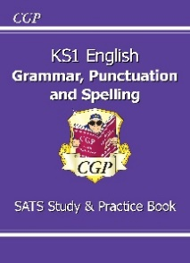
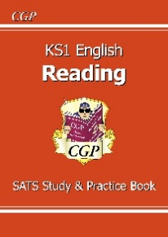
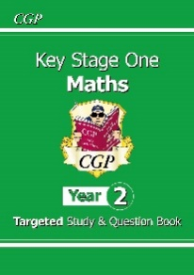

In Year 2 for home learning the children are going to be working though CGP book because the tasks in these books are linked to what we are doing in class. Each week the children will be sent on with one or two of these books and the tasks they will be required to do will be written inside the front cover. The children will also be able to choose some tasks to do related to our topic work and these tasks can be found below.
In English we will be reading this story first:
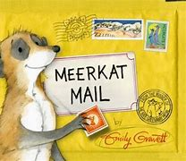
These websites might be useful:
https://www.youtube.com/watch?v=DcwuTRQ16MU
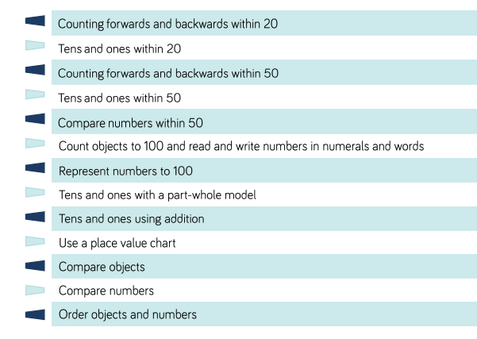
In Maths we will be learning to

These websites might be useful:
https://www.topmarks.co.uk/maths-games/hit-the-button
https://www.topmarks.co.uk/ordering-and-sequencing/caterpillar-ordering
https://www.primarygames.co.uk/pg2/splat/splatsq100.html
https://www.youtube.com/watch?v=vzeeaxLQDkE
https://www.youtube.com/watch?v=62I4wPTmKhM
https://www.youtube.com/watch?v=fksle3ZcYF8
Please select and complete at least 3 of the tasks below. On Wednesday ??????, please bring your Home Learning so we can share your fantastic home learning in class and we will display as many of the items as possible. I hope you enjoy developing your own knowledge and understanding.
Task 1  Animal groups  https://www.bbc.co.uk/bitesize/topics/z6882hv  Watch these clips and try to answer the following questions:  What are mammal?  What are amphibians?  What are birds?  What are fish?  What are reptiles?  What are minibeasts?  Divide a piece of paper into 6 and draw one of each type of animal. | Task 2  Discover what a Habitat is by watching ‘ Habitats: What is a habitat?’ by Discovery Education https://www.youtube.com/watch?v=ZrSWYE37MJs | Helpful hints:  Tick the activities and date them when you have completed them.  For finding out activities, use: the internet safely ,  books ,  other people ,  library,  things you’ve learned in school.  You can use:  pencil & paper ,  cameras ,  tablets ,  smart phones ,  PCs ,  anything you want: be creative!
Task 3  Pick an animal to make a habitat for. Create a shoe-box habitat (pictures included). Can your child explain how the animal is suited for that specific habitat?  Take photographs of your habitat and email them into school for our classroom habitats display.  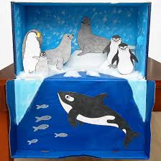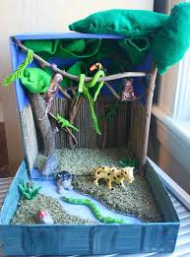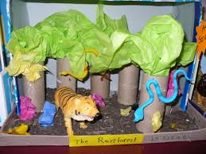 | Task 4  What do all animals need to survive?  https://www.bbc.co.uk/bitesize/topics/z6882hv/articles/zx38wmn  Create a fact sheet telling people about the things that animals need to service. Remember to include a diagram.
Task 5
Food Chains
https://www.bbc.co.uk/bitesize/topics/z6882hv/articles/zx38wmn
This lesson includes: one video/five activities to reinforce learning.
Create your own food chain diagram.
https://www.youtube.com/watch?v=n0qw3Uy5YQ8
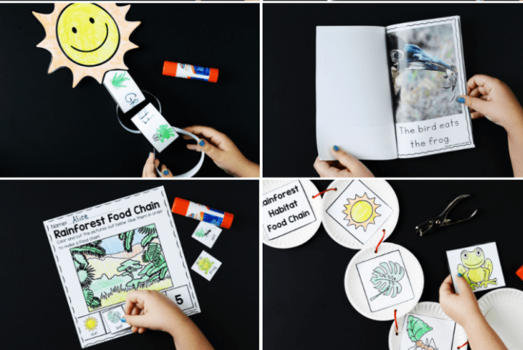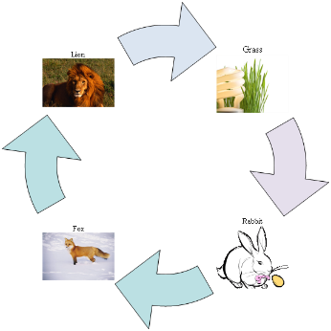

Task 6
Research your favourite animal and create a fact file for us to read. 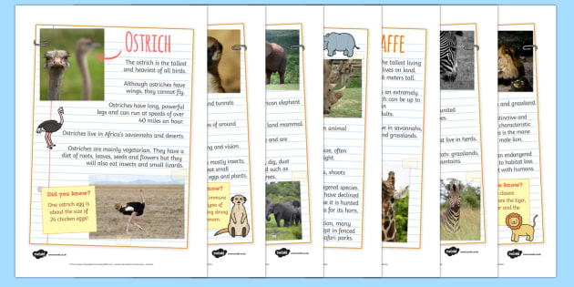
If you have any questions, please speak to me or Mrs Smith. We hope you enjoy your learning.

