Year 2 Home Learning
Set on: 11.06.21
Due into school on: 12.07.21
In English we will be looking at these stories and genres: Narrative
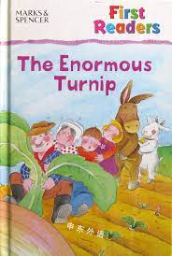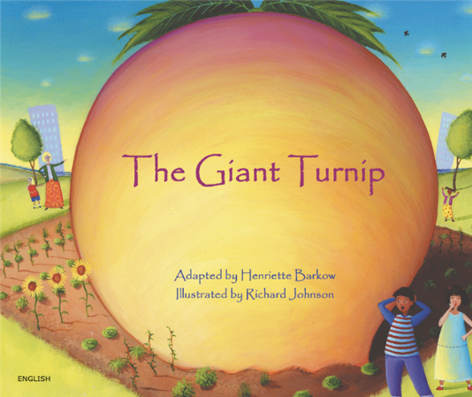
These websites might be useful:
The Giant Turnip (bilingual children's book) - YouTube
The Enormous Turnip (Retold by Irene Yates) I Read Aloud I Classic Tales - YouTube
We will focus on these spellings each week:
07.06.21 | 14.06.21 | 21.06.21 | 21.06.21 | 05.07.21 | 12.07.21
wild  climb  most  only  both  old  cold  gold  hold  told | every  great  break  steak  pretty  beautiful after  fast  last  past | father  class  grass  pass  plant  path  bath  hour  move  prove | improve  sure  sugar  eye  could  should  would  who  whole  any | many  clothes  busy  people  water  again  half  money  Mr  Mrs | parent Christmas everybody even  once  friend  said  our  where  there

In Maths we will be learning to:
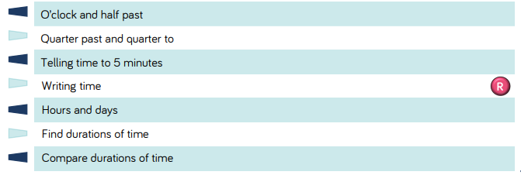
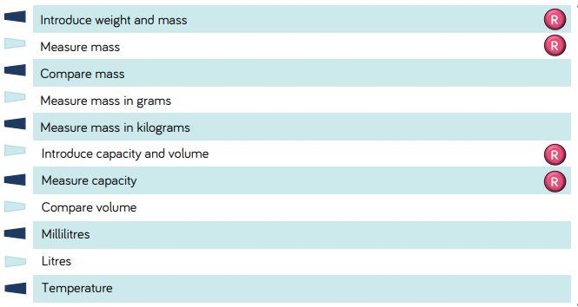

These websites might be useful:
https://www.topmarks.co.uk/maths-games/hit-the-button
Measuring Games (topmarks.co.uk)
time - Topmarks Search
Please select and complete at least 3 of the tasks below. When complete, please bring your tasks into school so that we can share your fantastic home learning in class and we will display as many of the items as possible.
Task 1  Make your own animal sock puppet or finger puppets.  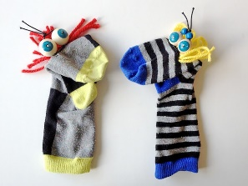  Dinosaur Sock Puppet - CBeebies - BBC  How to Make a Sock Puppets - YouTube  Paper puppets: Finger puppets for children | Animal puppets - YouTube  Create a puppet show using your puppets. Take photos of your puppets to bring into school. | Task 2  What makes some places sacred to believers?  Find out about a place that is sacred. You can find out about one or more of the following places:  Church  Synagogue  Temple  Mosque  Gurdwara  Draw a picture of the sacred place and write about what you find out about each place. | Helpful hints:  Tick the activities and date them when you have completed them.  For finding out activities, use:  -The internet  -Books  -Other people  -The library  -Things you’ve learned in school.  You can use:  -Pencil & paper  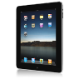  -Cameras  -Tablets  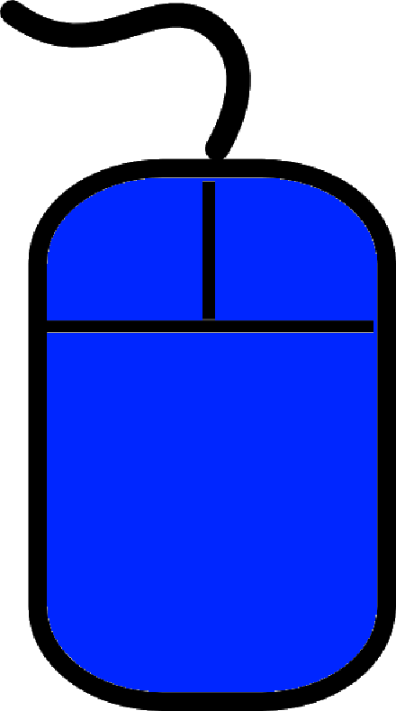  -Smart phones  -PCs  -Anything you want. Try and be as creative as you can!
Task 3  Find out about the basic needs of plant. What do they need to survive?  Create a leaflet or poster to show people how to look after a plant.  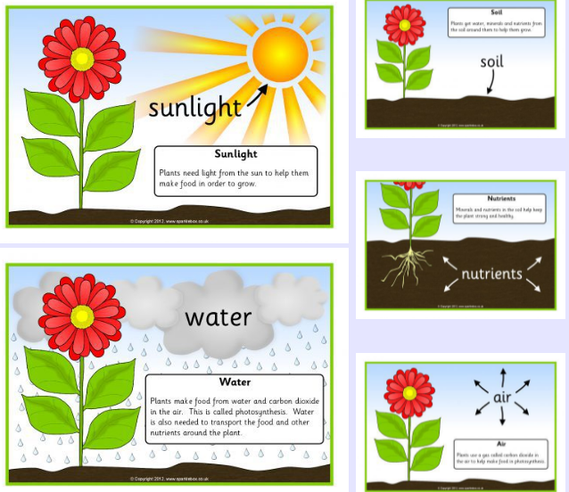 | Task 4  Have a look at different plants and trees. What would you measure them in? cm/m/mm  Measure the height of three of them.  Plants your own seeds and use the ruler to measure the plant every few days. Make sure you keep a diary.  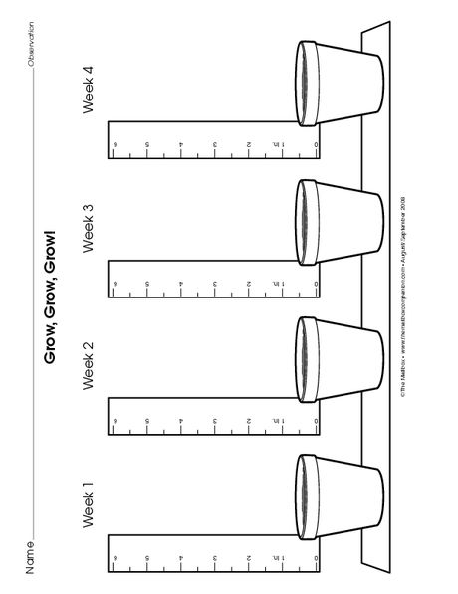  Have a look at your data. How much did your plant grow altogether? Which day did it grow the most? Which day did it grow the least?
Task 5
Describe what humans use plants for.

Sort different plants into groups of what we eat and don’t eat.
Cut out pictures of food and sort the pictures into groups of what we eat and don’t eat.
Create a healthy snack using the plants that you eat.
Plant Parts We Eat - YouTube
6 Parts of the Plant We Eat - YouTube
Food From Plants | Science For Kids | Periwinkle - YouTube
Task 6
Make you own paper clocks to help you tell the time. Practise tell the time to the hour, half hour and quarter to and past the hour.
How to make a paper plate clock - Mum In The Madhouse
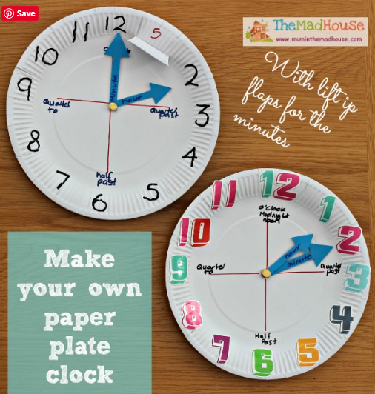

If you have any questions, please speak to me or Mrs Smith. We hope you enjoy your learning.

