Year 4 Home Learning
Set on: 11.06.21
Due into school on: 12.07.21
In English we will be looking at these stories and genres: Beasts of Olympus Beast Keeper
- Non-chronological reports
- Narratives
- Explanations texts
These websites might be useful:
- https://www.bbc.co.uk/bitesize/subjects/zv48q6f
- https://www.bbc.co.uk/teach/class-clips-video/english-ks1-ks2-how-to-write-a-non-chronological-report/zvbtscw
- https://www.bbc.co.uk/bitesize/topics/zx339j6

We will focus on these spellings each week:
Tested on 18.6.2021  homophones and near homophones | Tested on 25.6.2021  homophones and near homophones | Tested on 2.7.2021  homophones and near homophones | Tested on 9.7.2021  homophones and near homophones | Tested on 16.7.2021  homophones and near homophones | Tested on 21.7.2021  contraction words
there  their  they’re  hear  here  quite  quiet  see  sea  knot  not | bare  bear  to  too  two  be  bee  night  knight  mail  male | meat  meet  berry  bury  rein  rain  peace  piece  break  brake  saw  sore | missed  mist  plane  plain  scene  seen  blue  blew  fair  fare  great  grate | through  threw  heel  heal  weather  whether  whose  who’s  reign  rein  dear  deer | can’t  didn’t  hasn’t  couldn’t  it’s  I’m  they’re  he’s  you’re  don’t

In Maths we will be learning to:
- Understand fractions
- understand decimals
These websites might be useful:
- https://www.bbc.co.uk/bitesize/topics/zhdwxnb
- https://www.bbc.co.uk/bitesize/topics/zsjqtfr

Please select and complete at least 3 of the tasks below. When complete, please bring your tasks into school so that we can share your fantastic home learning in class and we will display as many of the items as possible.
Task 1  Create a fact file about the Battle of Tipton Green. Include detailed information about what happened and pictures.  https://en.wikipedia.org/wiki/Battle_of_Tipton_Green  http://www.tiptoncivicsociety.co/p/a-brief-history-of-tipton.html | Task 2  Make a board game that can be used to teach the times tables. Remember to include a set of instructions.  https://www.instructables.com/Build-your-Own-Board-Game/  https://www.wikihow.com/Make-Your-Own-Board-Game | Helpful hints:  Tick the activities and date them when you have completed them.  For finding out activities, use:  -The internet  -Books  -Other people  -The library  -Things you’ve learned in school.  You can use:  -Pencil & paper  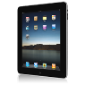  -Cameras  -Tablets  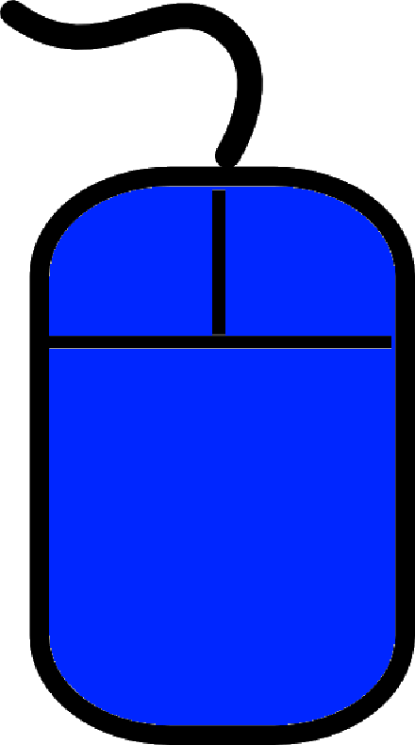  -Smart phones  -PCs  -Anything you want. Try and be as creative as you can!
Task 3  Invent and make your very own pizza! Collect information from your family about their favourite pizza toppings and then make a pizza big enough for everyone to have an equal slice. Use what you have learnt about fractions to divide your pizza into equal slices. What fraction will you need to divide your pizza into?  Write down the recipe to share with the class. | Task 4  Use the internet and books to research information about the Greek Gods and Goddesses. Use the information you have learnt to create a fact file about your favourite Greek God or Goddess.  https://www.youtube.com/watch?v=eJCm8W5RZes  https://www.ducksters.com/history/ancient_greek_mythology.php
Task 5
Research different mythical creatures and then use the information you have found out to create a mythical creature of your own. Remember to give your mythical creature a name and write a detailed description of it. You can be as creative as you can and make a model of it too!
Task 6
Write your own mythical story like those written about Ancient Greece. Think about what we have read in our class text Beasts of Olympus and what we have learnt about Greek Gods.
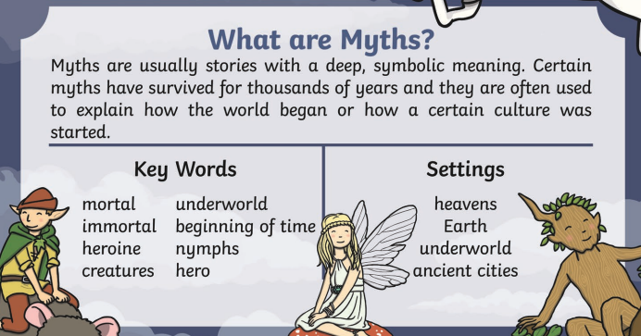

https://www.youtube.com/watch?v=7RTdNnf6cgY

https://www.bbc.co.uk/teach/school-radio/ks2-ancient-greece/zk73nrd

If you have any questions, please speak to me or Mrs Lal. We hope you enjoy your learning.

