Year 3 Summer Term Home Learning
Set on: 11.06.21
Due into school on: 12.07.21
In English we will be looking at these stories and genres:
- Myths and Legends
- Explanation texts
- Diary writing
- Poetry
Quality Text: The Sleeping Sword by Michael Morpurgo
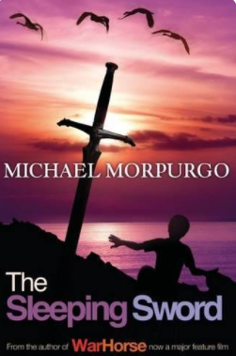

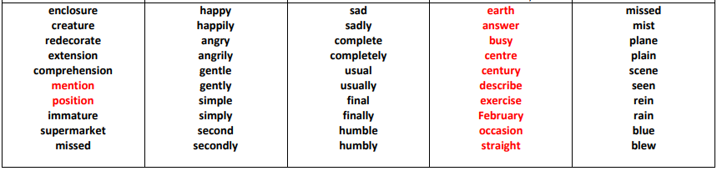
We will focus on these spellings each week:
Test will take place on Wednesday every week. You can practise these spellings on Purple Mash – Y3 Summer 1
w/b 14.6.21- Week 1 | w/b 21.6.21- Week 2 | w/b 28.6.21- Week 3 | w/b 5.7.21- Week 4 | w/b 12.7.21- Week 5

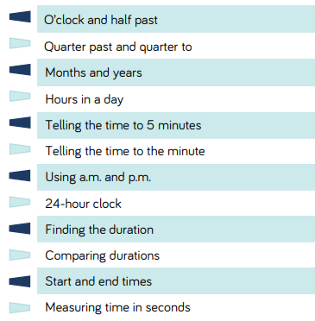
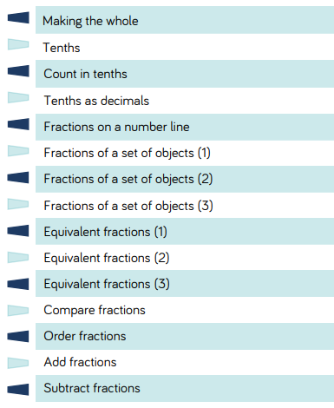
In Maths we will be learning to:
These websites might be useful for maths:
https://www.topmarks.co.uk/maths-games/hit-the-button
https://www.topmarks.co.uk/times-tables/coconut-multiples
https://www.topmarks.co.uk/maths-games/mental-maths-train

Year 3 Summer Term Home Learning - Set on: 11.06.21
Please select and complete at least 3 of the tasks below. When complete, please bring your tasks into school so that we can share your fantastic home learning in class and we will display as many of the items as possible.
Crack the Code- Anglo-Saxon Runes  Can you write a secret message for somebody using the ancient Anglo-Saxon alphabet?  Use the Anglo-Saxon runes at the bottom of the page to help you? Can your partner crack the code to read your secret message? | Archaeology Diary  You are an archaeologist who has dug up a box of Anglo-Saxon artefacts. What could be inside? Describe in a diary entry, using adjectives and similes, what you found.  https://www.twinkl.co.uk/resource/dear-diary-diary-writing-frame-t-l-892 | Helpful hints:  Tick the activities and date them when you have completed them.  For finding out activities, use:  -The internet  -Books  -Other people  -The library  -Things you’ve learned in school.  You can use:  -Pencil & paper  -Cameras  -Tablets  -Smart phones  -PCs  -Anything you want. Try and be as creative as you can!
Summer Poem  Write a poem of your choice about Summer and school holidays. You could write a kenning poem, a haiku, rhyming poem or any other type of poem of your choice.  Kennings Poetry Explained KS2 - https://www.youtube.com/watch?v=7AC0GjfIldM | Character descriptions  Write a character description of your favourite book character from your favourite books. Which descriptive language can you use?  https://www.twinkl.co.uk/resource/t-l-53913-character-profile-writing-template
Shoebox Garden  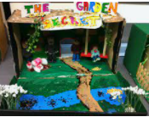  Make a miniature garden in shoebox! You can use any materials you like. How will you design your garden?  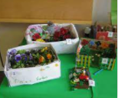 | Plant Model Making  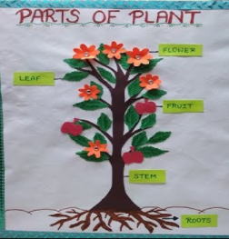  Make a model of a plant using natural resources, card, cardboard, paper or plasticine.
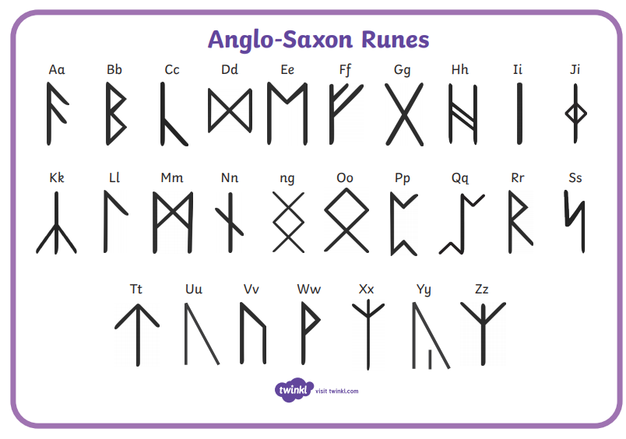

If you have any questions, please speak to any Year 3 staff. We hope you enjoy your learning.

